**SRS For Major Project**

**Content**

1. **Project Introduction**

**Introduction**

This Web Portal is developed for creating an interactive job vacancy From Particular Company for candidates.

This web application is to be conceived in its current form as a dynamic site-requiring constant updates both from the seekers as well as the companies. Apart from job-seekers and Companies (Job Provider) there will be an admin module to manage complete Portal as well as jobseeker and companies.

The Hiring of Candidates For Job Which is Posted By Particular Company Is based On Assessments which is from Company on the Basis of Company Requirement. Job Seekers Can apply for a particular Job and an Application Id is assigned to the applicant with on-line verification carried out using Aadhar Number and Registered Mobile.

This Computerised Paperless Examination Assessment System is providing a Hiring of Job in Company.

**Purpose**

The Purpose of Designing Online Computerised Paperless Examination is to gives the Job Seekers a Platform for finding a Right and a Satisfactory Job According to their qualification and need.

It Also Connect The Job Seekers With Major Companies. This Online Computerised paperless examination is created for providing all categories of job and help to get various types of jobs in various fields.

The main purpose of this online computerised paperless examination system is to provides the facility to job seekers for getting the quick jobs during there academic duration or after this.

**System User**

Admin Candidate/Applicants Company

**Admin Features**

Manage Complete Jobseeker Section. Like: Activate/Deactivate/Delete/ Edit Jobseeker’s Information. Admin user can view the jobseeker’s applications for each job.

Manage complete employer section. Admin user can activate/deactivate/delete/ edit company information. Manage posted jobs. Like: activate/deactivate/delete/edit posted job. Manage whole Web Portal content. Dynamic CMS is included to manage the content of the website. Admin Manage the Examination Section (Complete Exam). Admin user can send message to any jobseeker or job provider.

Admin user can send bulk emails as well. Manage newsletters section. Manage success stories (Manage Dashboard). Admin user can manage and handle the prohibited words for whole web Portal. Admin user can add/edit countries, cities, Package range, qualification, institutes, job industries, website ads.

**Job Provider/Company Features**

After registration job provider can perform following action: Add / Edit company’s profile Post new job vacancies With Job Complete Details And Exam Details Edit / Deactivate posted jobs Job provider can see the list of jobseekers who has applied for the job Job provider can search jobseekers Job provider can Manage Examination For Hiring Candidate . Job provider can send message to any job seeker. Job Seekers Features: Register on Web portal Apply Online for desire job in Particular. Add/Edit profile information including qualification, experience, and skills.

**Job Seekers Features**

Register on Web portal Apply Online for desire job in Particular.

Add/Edit profile information including qualification, experience, and skills.

1. **Requirement Analysis**

**Functional Requirement**

* Candidate Functionality
* Job Seeker Sign In
* Job Seeker Sign Up
* Job Seeker can view all available jobs
* Job seeker can search based on advanced search
  + Advanced search can be done on role, salary, technology, etc.
* Job seeker can upload resume
* Job seeker can view all applied jobs.
* Job seeker can update their profile information.
* Job seeker can retrieve their password if forgot.
* Admin and Company Functionality.
* Companies can register to the portal.
* Admin approves the company registration,
* Companies can post jobs.
* Companies can see applications.
* Companies can see all approved jobs.
* Companies can download resumes uploaded.
* Admin can view all jobs.
* Admin approves the jobs posted by the company.
* Database holding all data.
* Login functionality for admins.

**Non-Functional Requirement**

The major difference between Functional and Non-functional difference lies in two keywords. “What” and “How”. While what the system does is described by its functional requirements, how the system achieves those quality attributes are discussed by the non functional requirements.

The non-functional requirements focus on the scalability of the system, security of the system, reliability and maintenance of the system which are ensured by verifying and validating the system. The proposed system meets the non-functional requirements like security by several form validations and password encryptions, reliability by maintaining integrity with error messages, controlling access of the users.

**Reliability requirements:** The system must perform accurately towards the administrator request. For example, when the administrator saves the edited details of the user, after he reviews the details later, they must be changed according to the latest details that was updated. Moreover, the client is not allowed to view the details that the administrator has. Besides that, the login form will have validity check to ensure that only the authorized users gain access to the system.

**Usability requirements**: This system should be user-friendly and easy to use so that users can perform their tasks nicely.

**Implementation requirements**: In implementing the system, it uses Netbeans as the main tool. This forms the front-end. At the back-end, the Apache and MYSQL will be synchronized and be used to maintain the information in the database. This is formed by the databases and other data stores.

**Security requirements:** User credentials should be encrypted so as to ensure confidentiality, integrity and availability and the project ideas should be protected so as to avoid being stolen by other parties.

1. **Design**

**View**

Examination Panel

* First candidate Login
* After login exam instruction are shown to candidate
* And start button at the bottom to start the exam
* After clicking on start timer is start
* No of question is showing in right side and showing the question is answered, marked or not answer
* Exam is submit by user or auto submit after time up
* After submit exam result is send to admin and shortlist student get result by mail

Candidate view

* Candidate login to panel
* In the panel candidate can edit profile, view test, apply for companies
* In edit profile candidate can add more details about candidates or edit details which he added
* In view test section candidate can select company and give test
* After test complete it get result and get correct answer for every wrong answer.

**Database Schema**

**Admin Table**

admin_id (varchar, primary key)

name (text)

password (text)

**Candidate Table**

candidate_id (varchar, primary key)

password (text)

name (text)

date_of_birth (date)

hsc percent (float)

ssc percent (float)

bachelor aggregate (float)

no_of_current_backlogs (int)

college_name (text)

skills (text)

phone number (long)

**Company Table**

Company_id (varchar, primary key)

Name (text)

Category (text)

Headquarters (text)

Job_profile (text)

Package (text)

Date_of _exam (date)

No_of_vacancies (int)

**Questions_bank Tables**

Question_id (varchar, primary key)

Question_category (text)

Question_statement (text)

Question_options (text)

**UML MODELLING**

**Use Case**

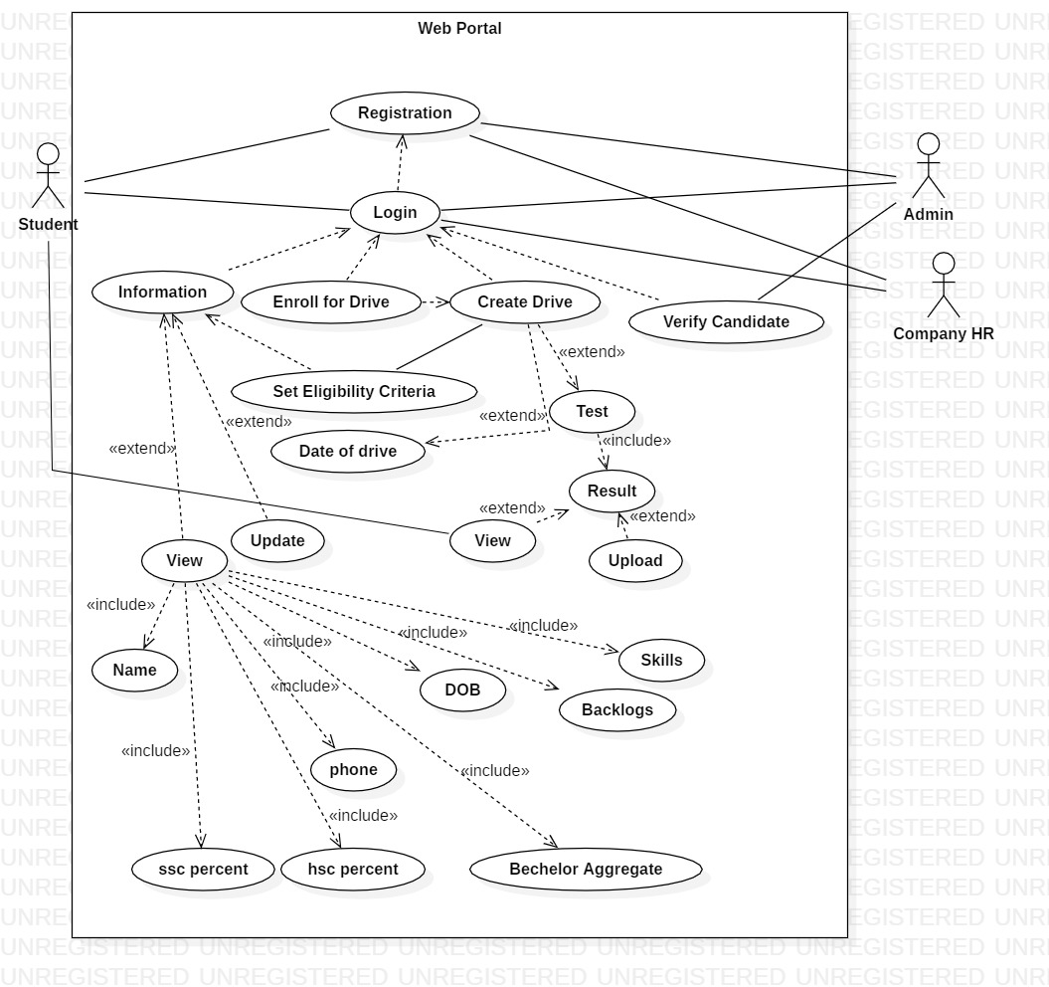

**Class Diagram**

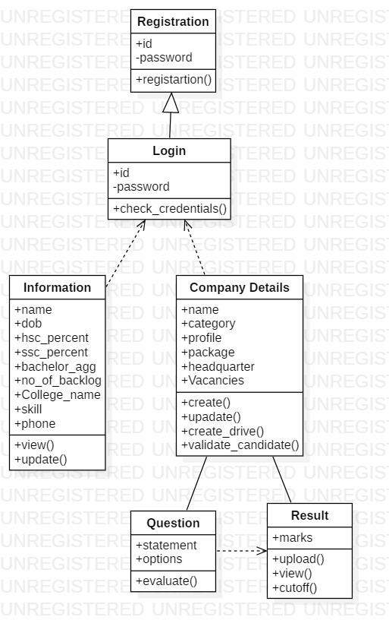

**Sequence Diagram**

